WEEK 3 ASSESSMENT
Project Title: Basic Network Discovery and Traffic Analysis
Department: Computer Science
Student Name: John-Suga Davou Nyam
Institution: University of Jos

TASK 1: Workstation and Network Interface Identification
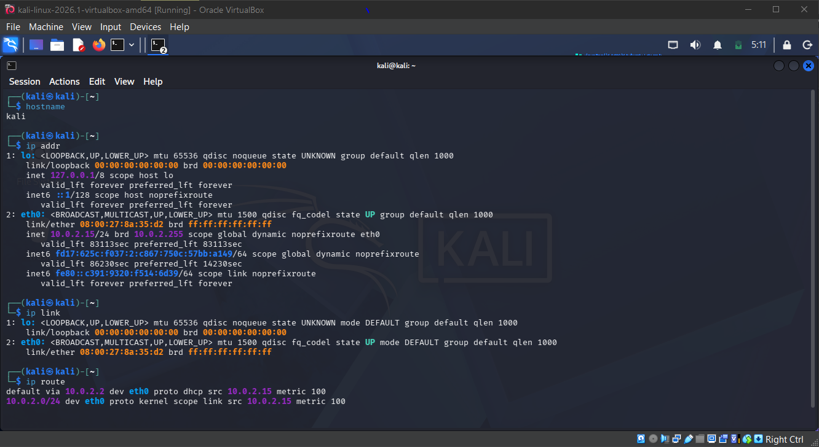
Hostname: kali
active network interface:eth0
IPv4 address:10.0.2.15
MAC address: 08:00:27:8a
default gateway:10.0.2.2

TASK 2: DNS Information
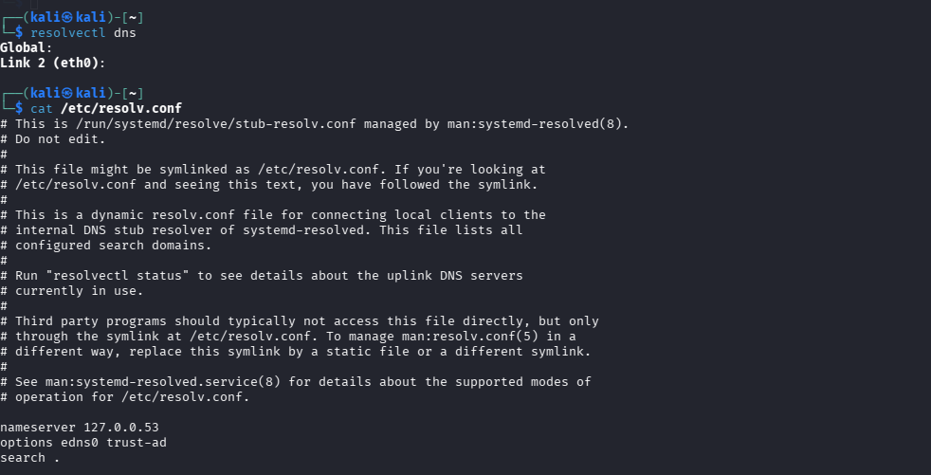
DNS server address: 127.0.0.53
DNS mode:stub
Upstream DNS server: not displayed

TASK 3: Connectivity Testing
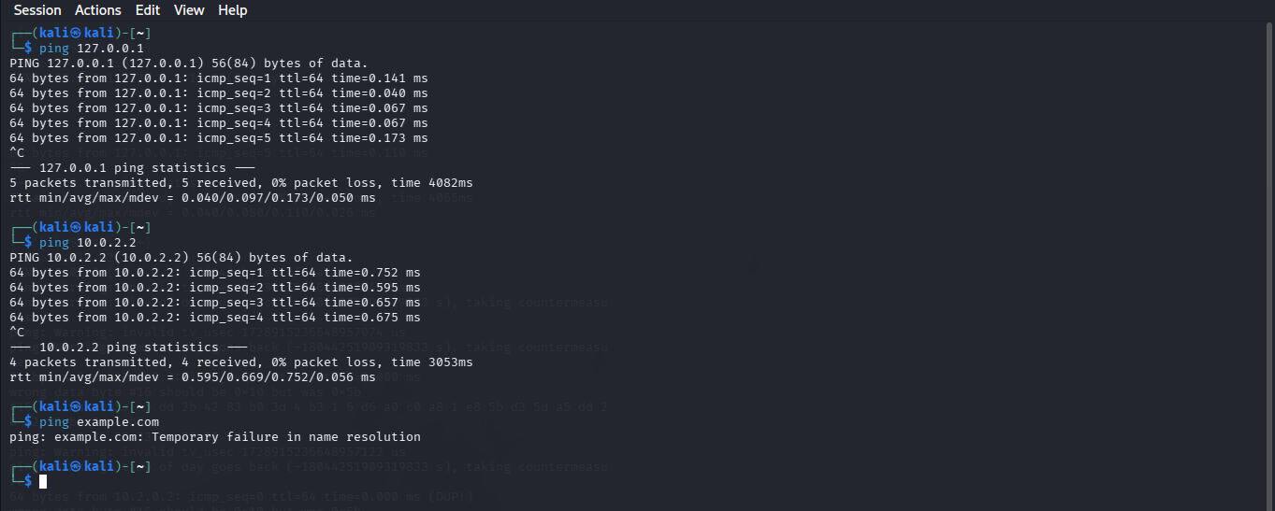

Destination | Reply | Meaning
127.0.0.1 | 5 received successfully 0% loss | Successful
10.0.2.2 | 4 received successfully 0% loss | Successful
example.com | Temporary failure in name resolution | Failed

TASK 4: DNS Lookup
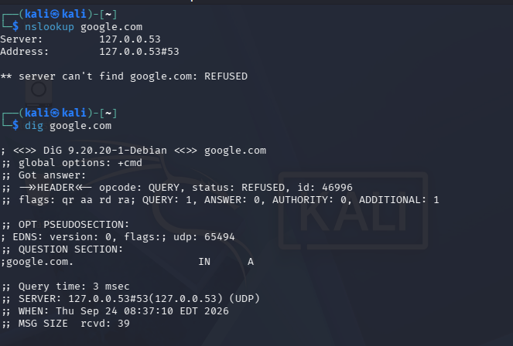
Domain queried: google.com
DNS server: 127.0.0.53
Returned IP address: DNS query was refused so no returned address.
What did DNS do during the test ?: it converted google.com to its IP address, so that it can connect to the server.

TASK 5: Route Investigation
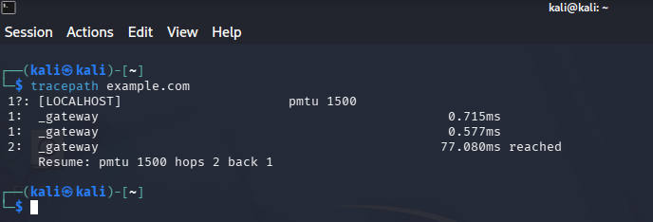
Visible Hops:
Hop 1: _gateway; 0.715ms and 0.577ms
Hop 2: _gateway; 77.080ms reached

HOP
This is a one router or gateway that a packet passes through on its way to the next device and the tracepath tool shows each one along its response time

TASK 6:Wireshark ICMP Capture
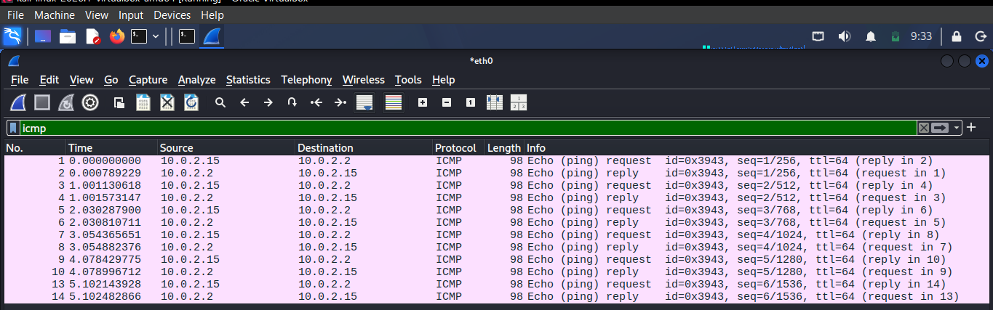

ICMP Echo Request | ICMP Echo Reply
Packet 1 | Packet 2
Source: 10.0.2.15 | Source: 10.0.2.2
Destination: 10.0.2.2 | Destination: 10.0.2.15
Protocol: ICMP | Protocol: ICMP

TASK 7:Wireshark DNS Capture
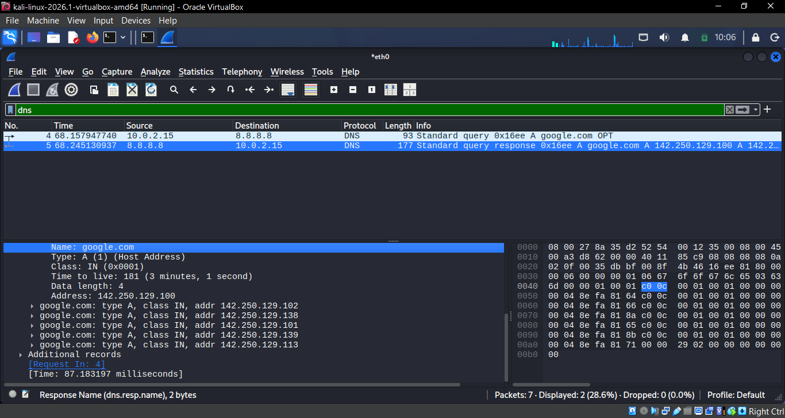

DNS Query:
- Source 10.0.2.15
- Destination 8.8.8.8
- Requested Domain name: google.com

Response:
- Source 8.8.8.8
- Destination 10.0.2.15
- IPaddress in response: 142.250.129.113

TASK 8: Network Diagram
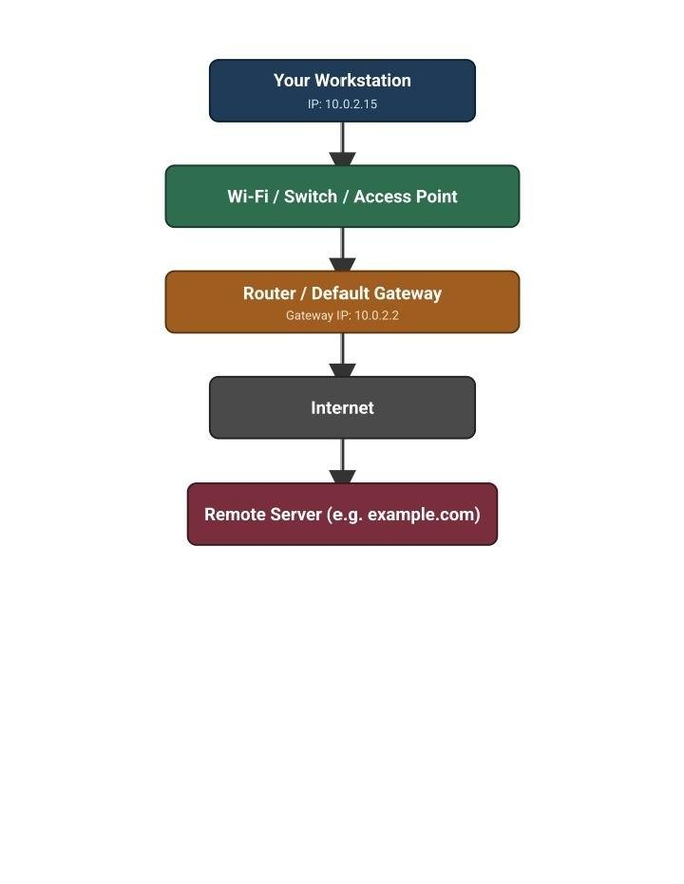

SECURITY OBSERVATION QUESTIONS
1. Purpose of an IP address? Identifies a device on a network.
2. IP vs MAC address? IP is logical/routable; MAC is a fixed hardware address.
3. Purpose of a default gateway? Sends traffic outside the local network.
4. What does DNS do? Translates domain names to IP addresses.
5. Why can a failed ping be misleading? ICMP is often blocked, even when the host is up.
6. Wireshark ICMP capture? Showed Echo request/reply packets with IPs, sequence numbers, and TTL.
7. DNS query and response? Query asked for example.com's IP; response gave 172.66.147.243.
8. Why inspect network traffic? To detect threats and troubleshoot issues.
9. Why capture only on authorised systems? Traffic may hold sensitive data; unauthorised capture is a privacy/legal risk.
10. Most useful concept? Ping — a quick way to test connectivity, and learning that a failed ping doesn't always mean the host is down.

Conclusion
This week covered DNS resolution, route tracing, and packet capture with Wireshark, giving practical insight into how devices communicate across a network. Tools like ping, tracepath, and Wireshark showed how traffic moves from a workstation through a gateway to reach its destination, and why analysts inspect this traffic to spot issues. These exercises reinforced core networking concepts — IP addressing, routing, and DNS — that are foundational to cybersecurity work.
Thank you.

